### Tugas

1. Install docker & docker compose

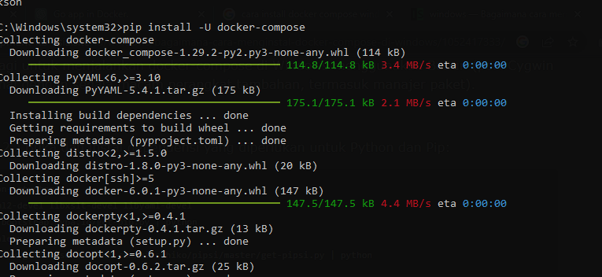

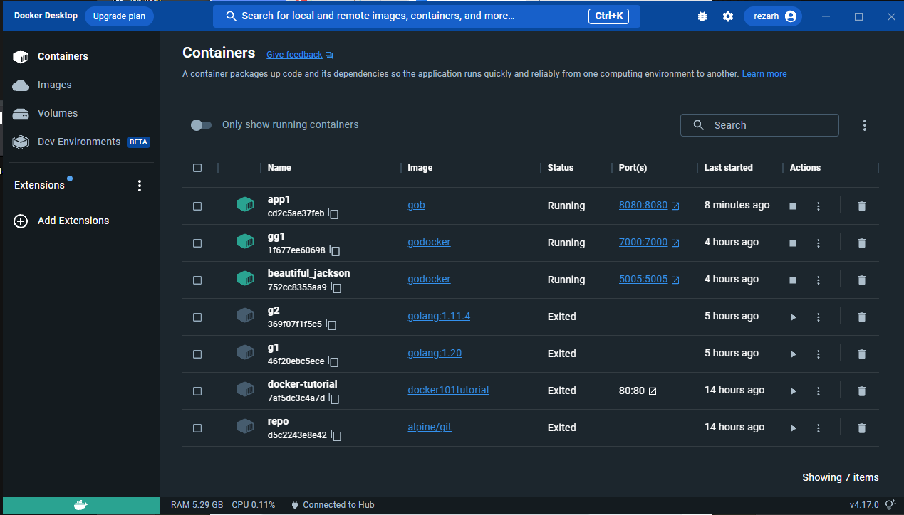

1. Create dockerfile.

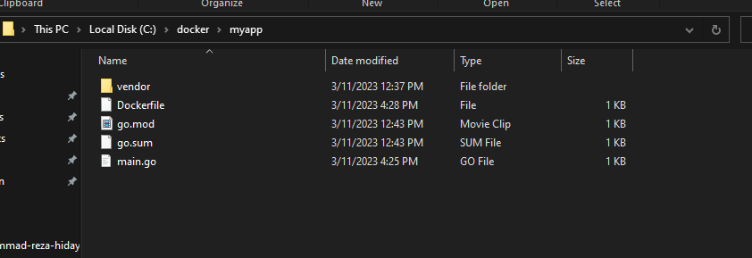

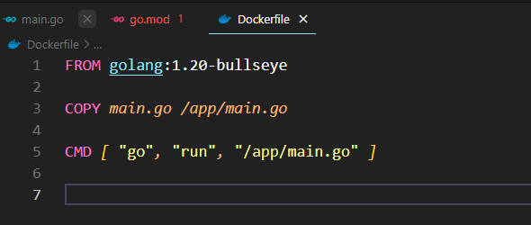

1. Clone your code and integrate to your dockerfile.

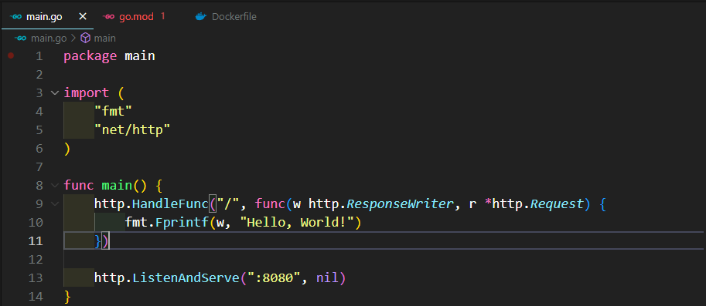

1. Build your container

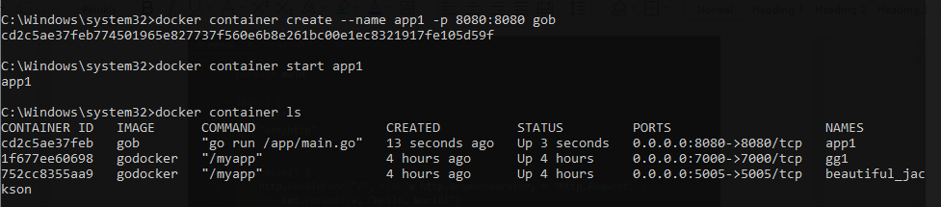

1. Push the image to docker registry

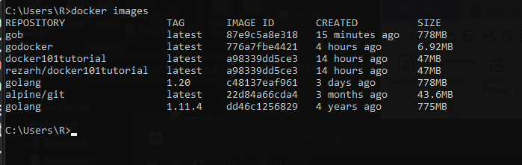

1. Deploy in your local machine

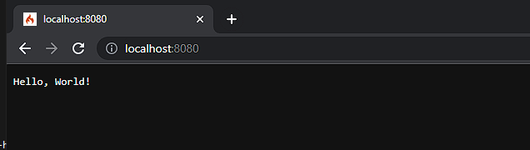

1. Try Docker Compose to run go app + mysql (optional)

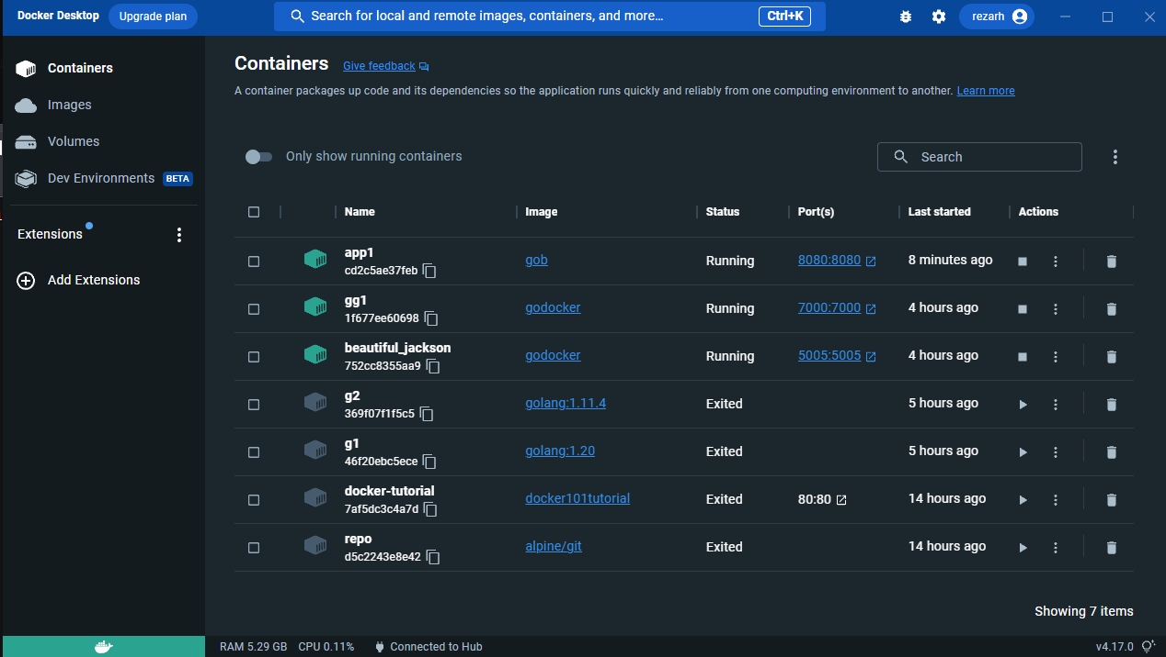

1. Try to Deploy in the Cloud (optional)

